Project Documentation
Import Data Using Transform Maps (Spreadsheet)
Platform: ServiceNow
Date: 01 October 2026

1. Introduction
Project Title: Import Data Using Transform Maps (Spreadsheet)
Team Members:
Name | Role
C. Abinayashree | Team Leader
Akshaya.R | Member
Ilakkiya. S | Member
Dhivya Dharshini.P | Member
Elackeya.M | member

2. Project Overview

Purpose
The project imports employee training records from a spreadsheet into ServiceNow using Import Sets and a Transform Map, links each record to an employee, and brings employee details such as the department into the record for easier reporting. It then secures the data with a custom role and Access Control Lists (ACLs), tested by impersonating users.

Features
- Custom table Employee Training Records with Training Name, Completion Date, Status and Employee fields.
- Bulk import of an Excel (.xlsx) file through Load Data into an import set (staging) table.
- Transform map with field maps that moves staged rows into the target table.
- Dot-walking to show Employee.Department on the form and list.
- Hr Manager role and user, added to the application menu and module.
- Read and write ACLs on the table that require the Hr Manager role.
- Access testing by impersonating an HR manager and another user.

3. Architecture
This project is built on the ServiceNow low-code platform instead of MERN, so each part of the template is described through its ServiceNow equivalent. There is no React, Node.js, Express.js or MongoDB code.

Frontend
Users work in the ServiceNow Next Experience (Platform UI) in a web browser. The interface is made of the application menu and module Employee Training Records, the list view, the record form (with the dot-walked Department field), and the Load Data and Transform Map forms used by the administrator.

Backend
The Now Platform server on the ServiceNow cloud instance does the processing. The Import Set loader reads the file and stages the rows. The transform engine applies the transform map and its field maps and writes the rows to the target table. The role and ACL engine checks every request.

Database
ServiceNow stores data in relational tables on the instance's cloud database. The tables used are:
Table | Purpose | Key fields
u_employee_training | Import set (staging) table created by Load Data | u_training_name, u_completion_date, u_status, u_employee
u_employee_training_records | Target table (Employee Training Records) | Training Name (String), Completion Date (Date), Status (Choice: In Progress, Completed), Employee (Reference to sys_user)
sys_user | Existing ServiceNow user table | Employee reference; Department is read by dot-walking

4. Setup Instructions

Prerequisites
- A ServiceNow instance (for example a Personal Developer Instance) and an account with the admin role.
- A web browser.
- A spreadsheet tool (Google Sheets or Excel) to create and download the .xlsx file.
- No Node.js, MongoDB or environment variables are needed.

Installation
- Sign in to the instance as an administrator.
- Open All > System Definition > Tables > New. Set Label to Employee Training Records, Name to u_employee_training_records, and tick Create module and Create mobile module.
- Add the columns Training Name (String), Completion Date (Date), Status (Choice) and Employee (Reference to sys_user), then Submit.
- Open the Status field and add the choices In Progress and Completed.
- Create a spreadsheet with columns u_training_name, u_completion_date, u_status and u_employee, and download it as .xlsx.
- Open All > System Import Sets > Load Data. Choose Create table, Label Employee Training, Name u_employee_training, Source File, Sheet number 1, Header row 1, then Submit.
- Open All > System Import Sets > Administration > Transform Maps and create a map (source: u_employee_training, target: Employee Training Records). Add field maps for the four fields.
- Click Transform under Related Links to run the import.
- Configure the form layout and add Employee.Department by dot-walking.
- Create the user (backup user) and the Hr Manager role, assign the role to the user, and add the role to the application menu and the module.
- Elevate to security_admin and create read and write ACLs on the table that require the Hr Manager role.

5. Folder Structure
ServiceNow has no client and server folders. The project is organised as records on the instance:
Instance (Application scope: Global)
|-- Application Menu: Employee Training Records
| `-- Module: Employee Training Records (roles: u_employee_training_records_user, Hr Manager)
|-- Tables
| |-- u_employee_training (import set / staging table)
| `-- u_employee_training_records (target table)
|-- Import Sets
| |-- Data source: Employee Training.xlsx
| `-- Transform Map: Employee Transform
| `-- Field Maps (4)
|-- Users and Roles
| |-- User: backup user
| `-- Role: Hr Manager
`-- Access Controls (ACL)
|-- u_employee_training_records read (requires Hr Manager)
`-- u_employee_training_records write (requires Hr Manager)

Template part | In this project
Client (React frontend) | Platform UI: application menu, module, list, form and layout
Server (Node.js backend) | Import set loader, transform map, roles and ACLs on the Now Platform

6. Running the Application
There are no npm commands. Use these steps instead:
Template step | In this project
Frontend: npm start in the client directory | Open the instance URL, sign in, then open All > Employee Training Records > Employee Training Records.
Backend: npm start in the server directory | The server runs on the cloud instance. To import data, open All > System Import Sets > Load Data, upload the file, then open the transform map and click Transform.

7. API Documentation
The project itself is operated through the UI. ServiceNow also exposes standard REST APIs for any table. The endpoints below are the platform's default Table API and Import Set API, shown for this project's tables. They are not custom endpoints, and the ACLs above also apply to them.
Method | Endpoint | Description
GET | /api/now/table/u_employee_training_records | List records. Optional parameters: sysparm_query, sysparm_limit, sysparm_fields
GET | /api/now/table/u_employee_training_records/{sys_id} | Get one record
POST | /api/now/table/u_employee_training_records | Create a record (JSON body)
PATCH | /api/now/table/u_employee_training_records/{sys_id} | Update a record
DELETE | /api/now/table/u_employee_training_records/{sys_id} | Delete a record
POST | /api/now/import/u_employee_training | Insert a row into the import set table
Example request
GET /api/now/table/u_employee_training_records?sysparm_limit=1
Accept: application/json
Example response (values are illustrative)
{
"result": [
{
"sys_id": "<record sys_id>",
"u_training_name": "Full Stack Java",
"u_completion_date": "2024-12-31",
"u_status": "ip",
"u_employee": {
"link": "https://<instance>.service-now.com/api/now/table/sys_user/<sys_id>",
"value": "<sys_id>"
}
}
]
}

8. Authentication
- Sign-in: users log in to the instance with their ServiceNow credentials. The browser then keeps a session, so no separate token handling is needed in the project.
- Authorization: access is role-based. The Hr Manager role is added to the application menu and module (so the menu is visible only to those roles) and to the read and write ACLs on u_employee_training_records.
- ACL evaluation: for each request ServiceNow checks the user's roles (and any conditions or scripts) against the ACL. A user without the role gets no access to the table.
- Changing ACLs: only users with the security_admin role can create ACLs, so the administrator uses Profile > Elevate Role first.
- Testing: the Impersonate User option confirms what each user can see without signing in as them.
- REST API: the Table API uses the same ACLs and is called with the instance's standard authentication (for example Basic or OAuth).

9. User Interface
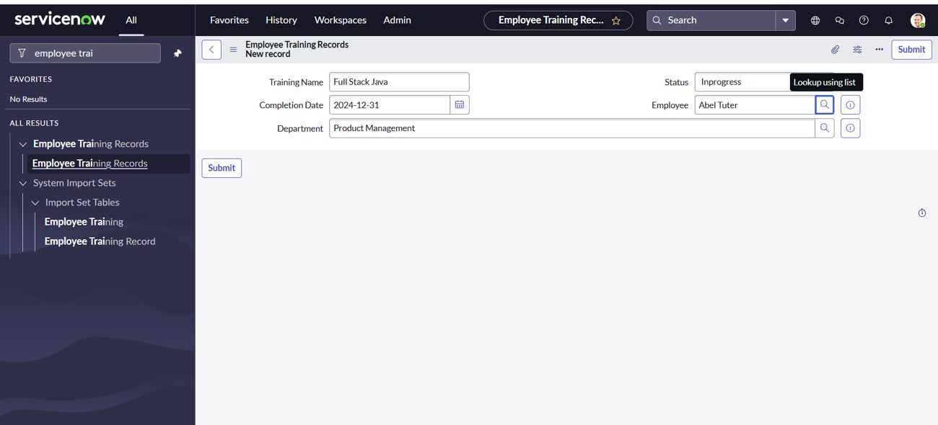
Figure 9.1: Employee Training Records form with the dot-walked Department field
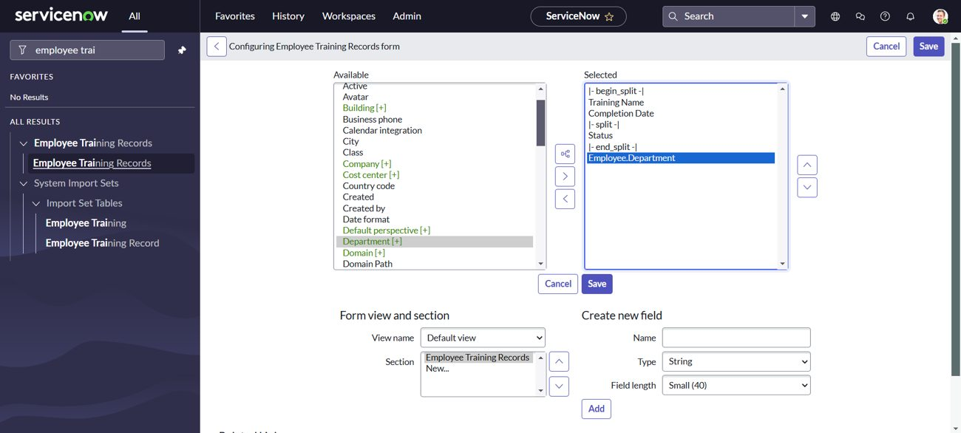
Figure 9.2: Form layout configuration with Employee.Department selected
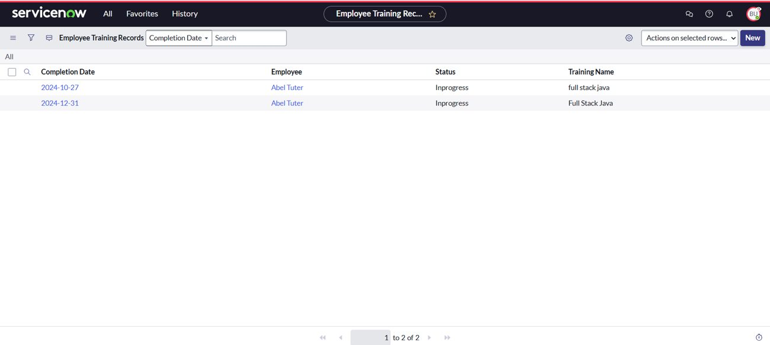
Figure 9.3: Employee Training Records list for a user with the Hr Manager role
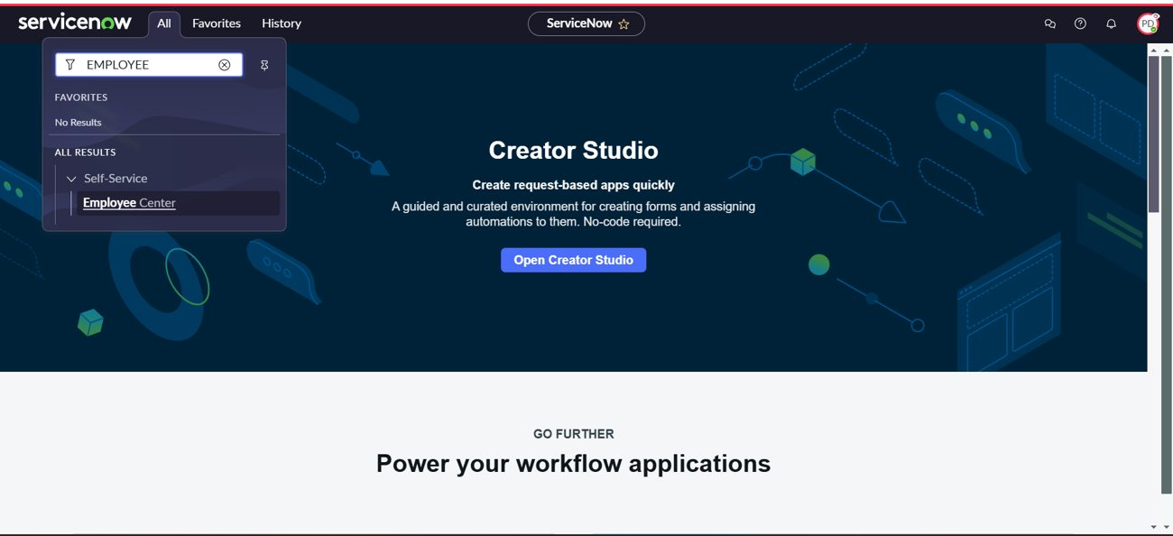
Figure 9.4: A user without the role cannot find the table

10. Testing
Testing strategy: User Acceptance Testing (UAT) was carried out after each part of the build, followed by access testing by impersonating users.
- Import testing: the import progress screen must show State Complete and Success, and the transform must finish with Transformation complete.
- Data checks: the new records appear in the target table, with the employee linked and the department shown.
- Access testing: impersonate a user with the Hr Manager role (records visible and editable) and another user (table not visible).
Tools: ServiceNow Import Set and Transform History, the Impersonate User feature, and list views of the tables. Summary of results:
Section | Total Cases | Not Tested | Fail | Pass
Table Creation | 4 | 0 | 0 | 4
Data Import | 3 | 0 | 0 | 3
Transform Map | 4 | 0 | 0 | 4
Dot-Walking | 2 | 0 | 0 | 2
Roles and Users | 4 | 0 | 0 | 4
Security (ACL) | 3 | 0 | 0 | 3
Result Testing (Impersonation) | 3 | 0 | 0 | 3
Totals | 23 | 0 | 0 | 23

11. Screenshots or Demo
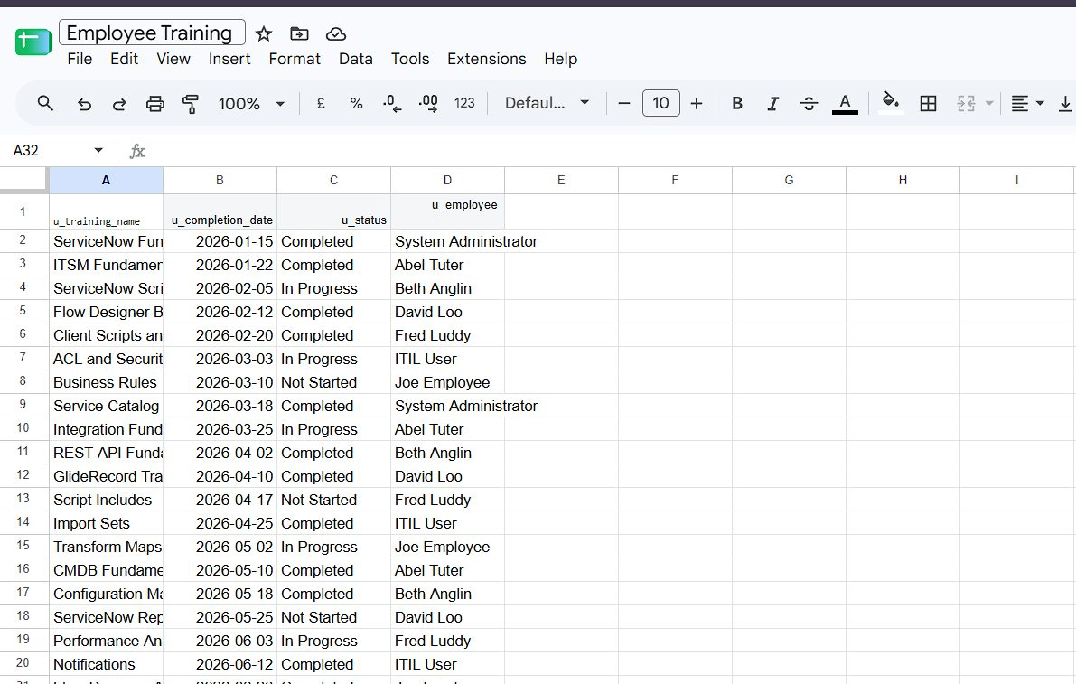
Figure 11.1: Employee Training spreadsheet (.xlsx)
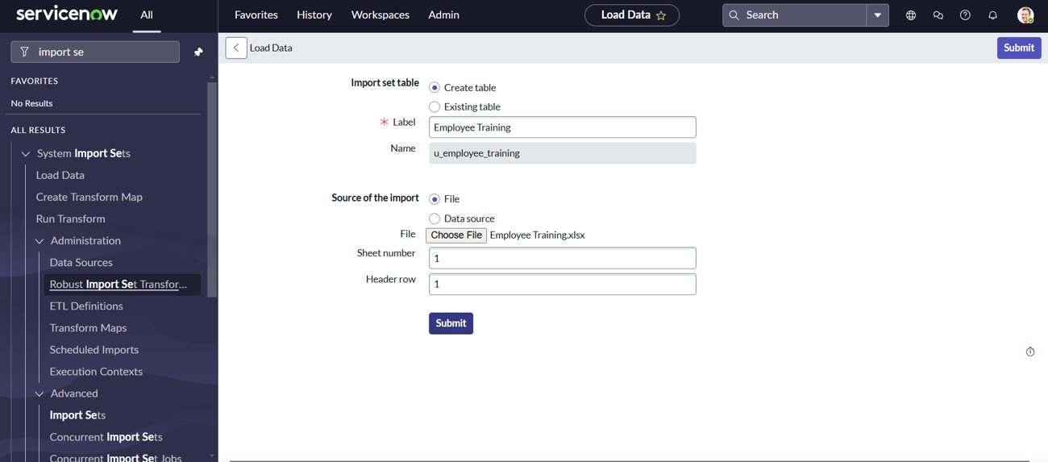
Figure 11.2: Load Data creates the import set table
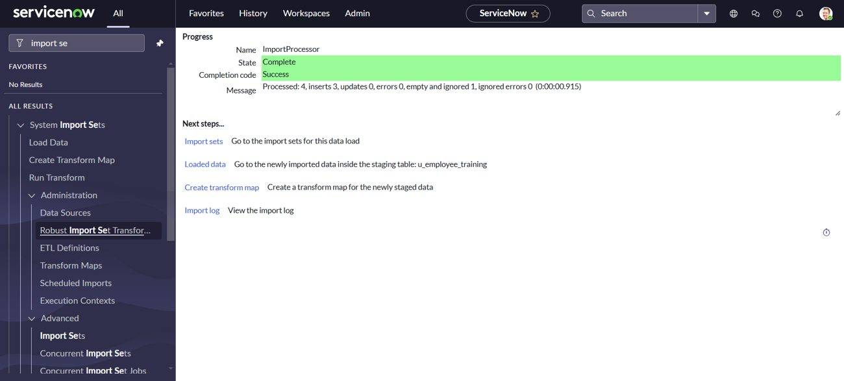
Figure 11.3: Import completed with Success
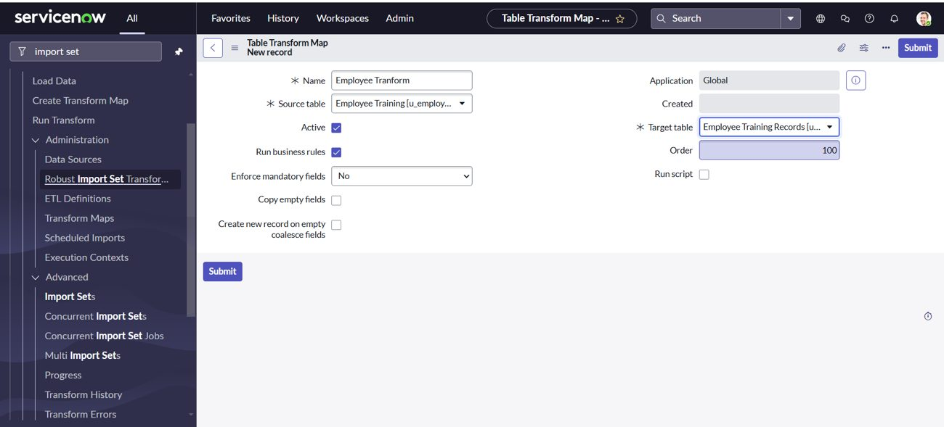
Figure 11.4: Transform map
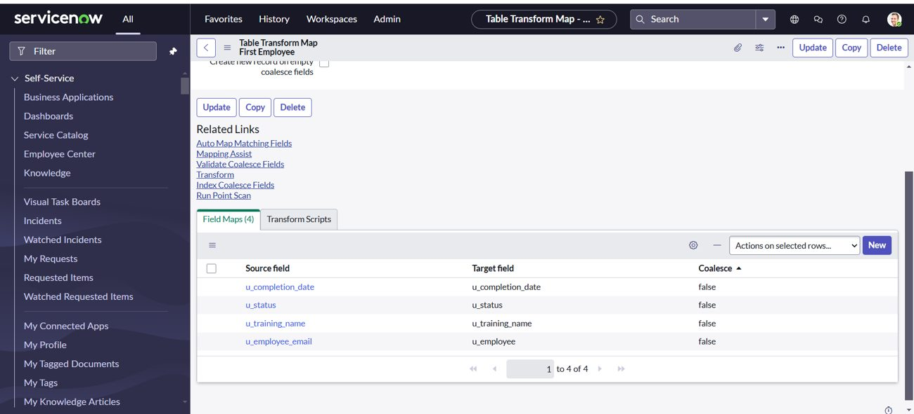
Figure 11.5: Field maps
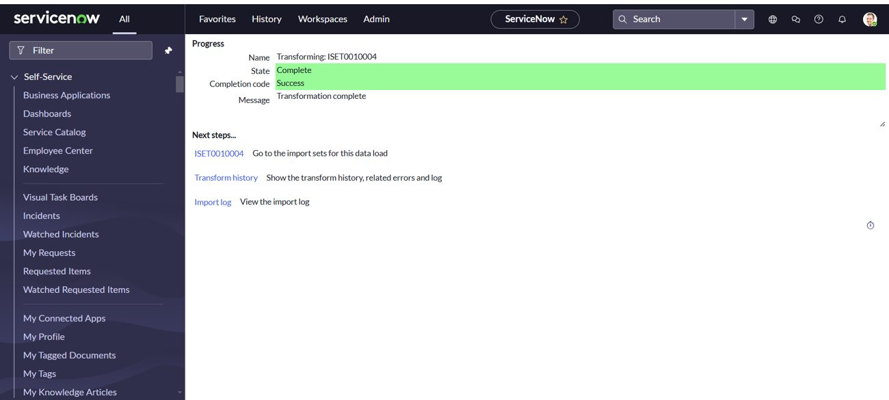
Figure 11.6: Transformation complete
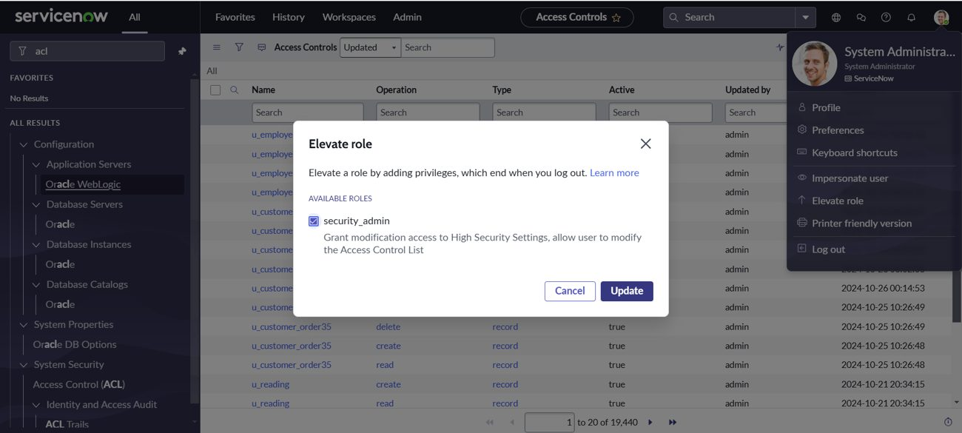
Figure 11.7: Elevating the role to security_admin
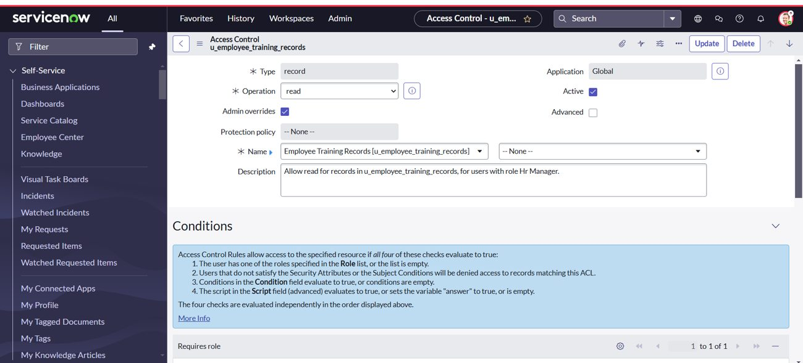
Figure 11.8: Read ACL
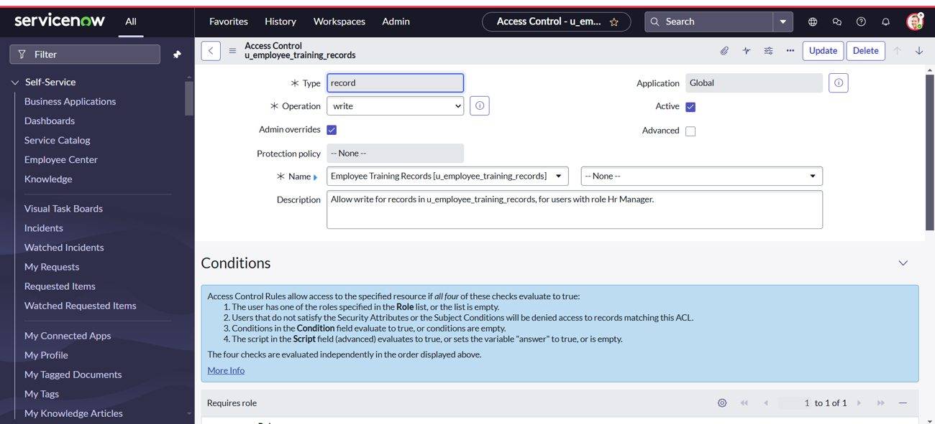
Figure 11.9: Write ACL
Demo link: [add your link here]

12. Known Issues
- Status values in the spreadsheet must match the choice values. A value such as Not Started is not in the Status choices (In Progress, Completed), so that row will not map correctly until the choice is added.
- Column names must match: the field map for Employee used a source column named u_employee_email, while the sheet header is u_employee. Keep the map and the sheet in step.
- Empty rows in the sheet are ignored by the import (the import result showed one empty row ignored).
- The Status choice label In Progress appears as Inprogress in some screens because of how the choice was entered.
- Running the transform again on the same import set can create duplicate records unless a coalesce field is set.
- Creating ACLs needs the security_admin role, which must be elevated each time.

13. Future Enhancements
- Set a coalesce field so repeated imports update existing records.
- Schedule imports so new spreadsheets load automatically.
- Add transform scripts or choice actions to clean dates and status values.
- Build dashboards and reports on training status by department.
- Send notifications for pending or overdue training.
- Add field-level ACLs for more sensitive fields.

